SimpliLearn

Sporty Shoes Documentation

Table of Contents

Tools 3

How Up the Application 3

Add MySQL credentials 3

Run the Application 4

Application Navigation 4

Registration 4

Admin 5

Home Page 5

Categories 6

Add Products 8

Order Details 10

User 11

GitHub 12

# Tools

* In this project I used the great knowledge learned in the course. Follow the tools I used in the process
  + Spring initializer to generate the project
  + Java 17
  + Spring boot Starter data JPA
  + spring-boot-starter-security
  + spring-boot-starter-thymeleaf
  + spring-boot-starter-web
  + MySQL
  + Spring Scurity
  + Eclipse

# How Up the Application

### Add MySQL credentials

* To create the MySQL DataBase follow the steps below
  + Open the application.properties located in src/main /resources
  + Fill the fields below with the credentials of you MySQL Data Base
    - spring.datasource.username
    - spring.datasource.password

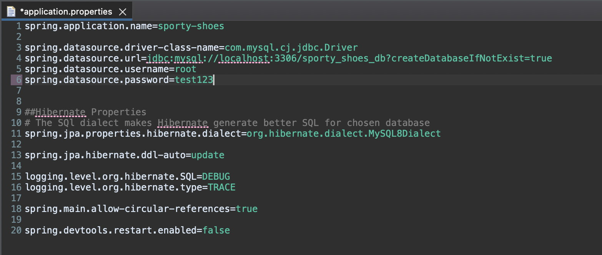

### Run the Application

* To up application run the SportyShoesApplication.java classe

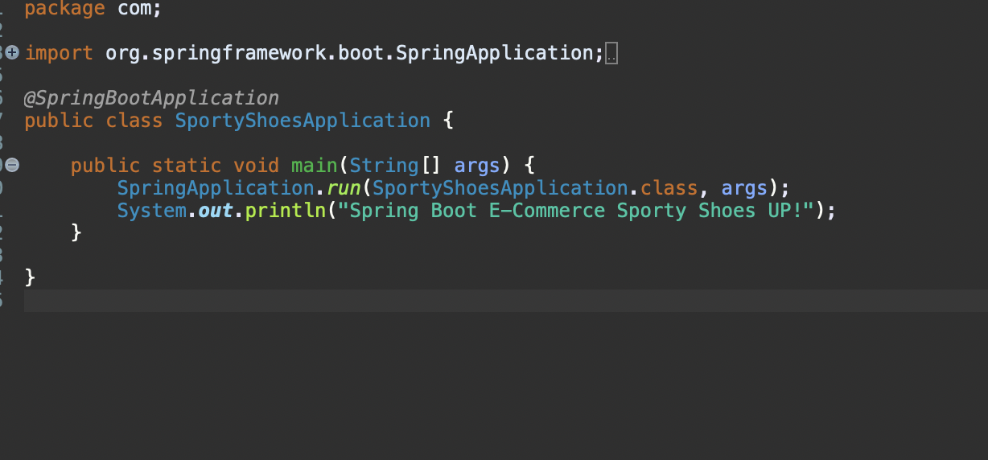

# Application Navigation

## Registration

* Up the application and go to <http://localhost:8080/login>
* Click on “Register Here” button

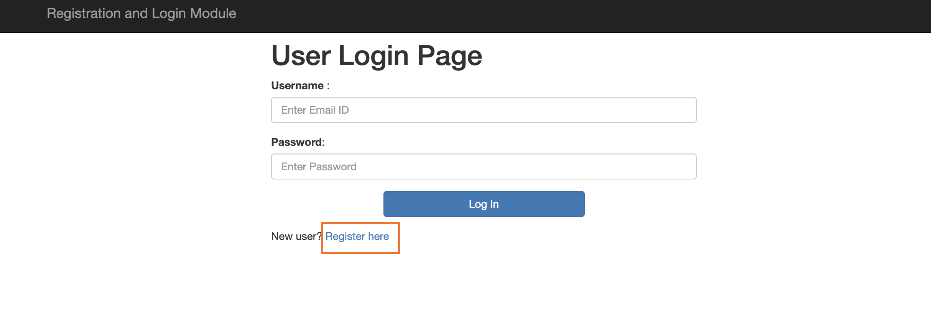

* Fill the fields First Name, Last Name, Email, Password and choose between Admin or regular User permition in the radio button

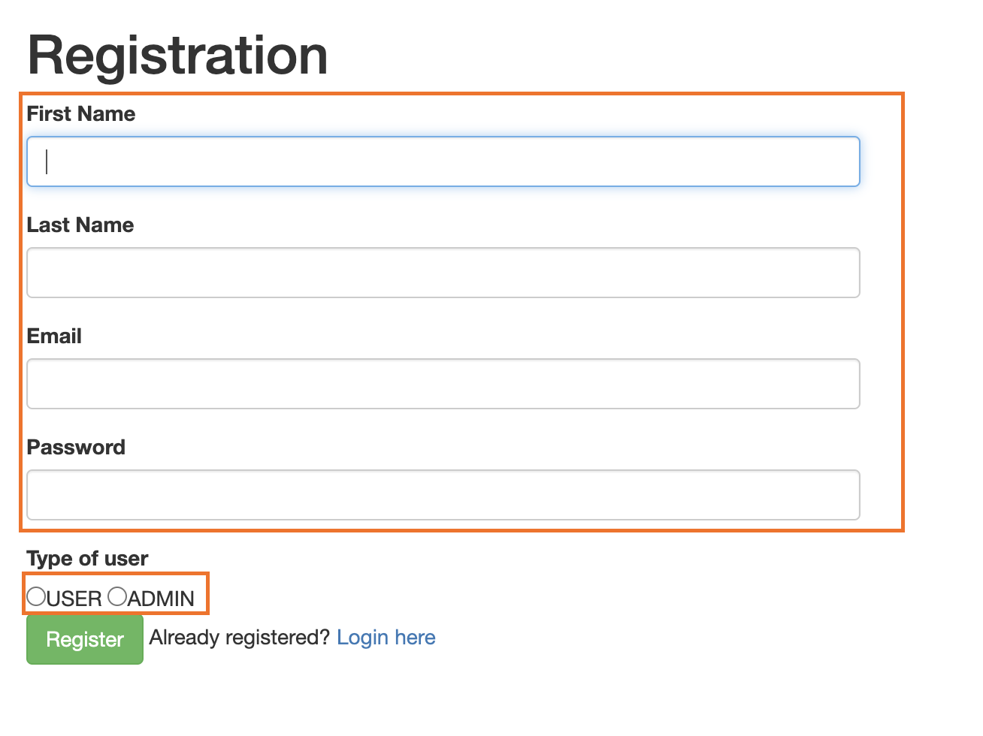

* Then click in the “Register” button
* A success message will be displayed
* Click on “Login Here” link
* Then you will be redirected to login page
* Fill with your user credentials

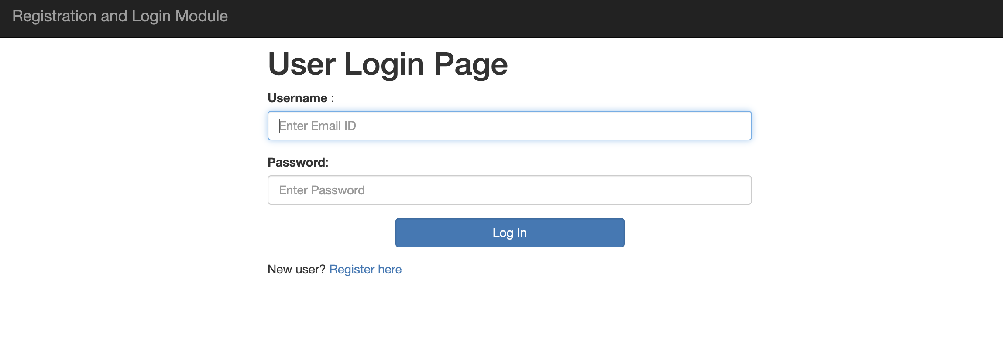

## Admin

### Home Page

* Login with your admin used
* Then you will be redirected to admin home page

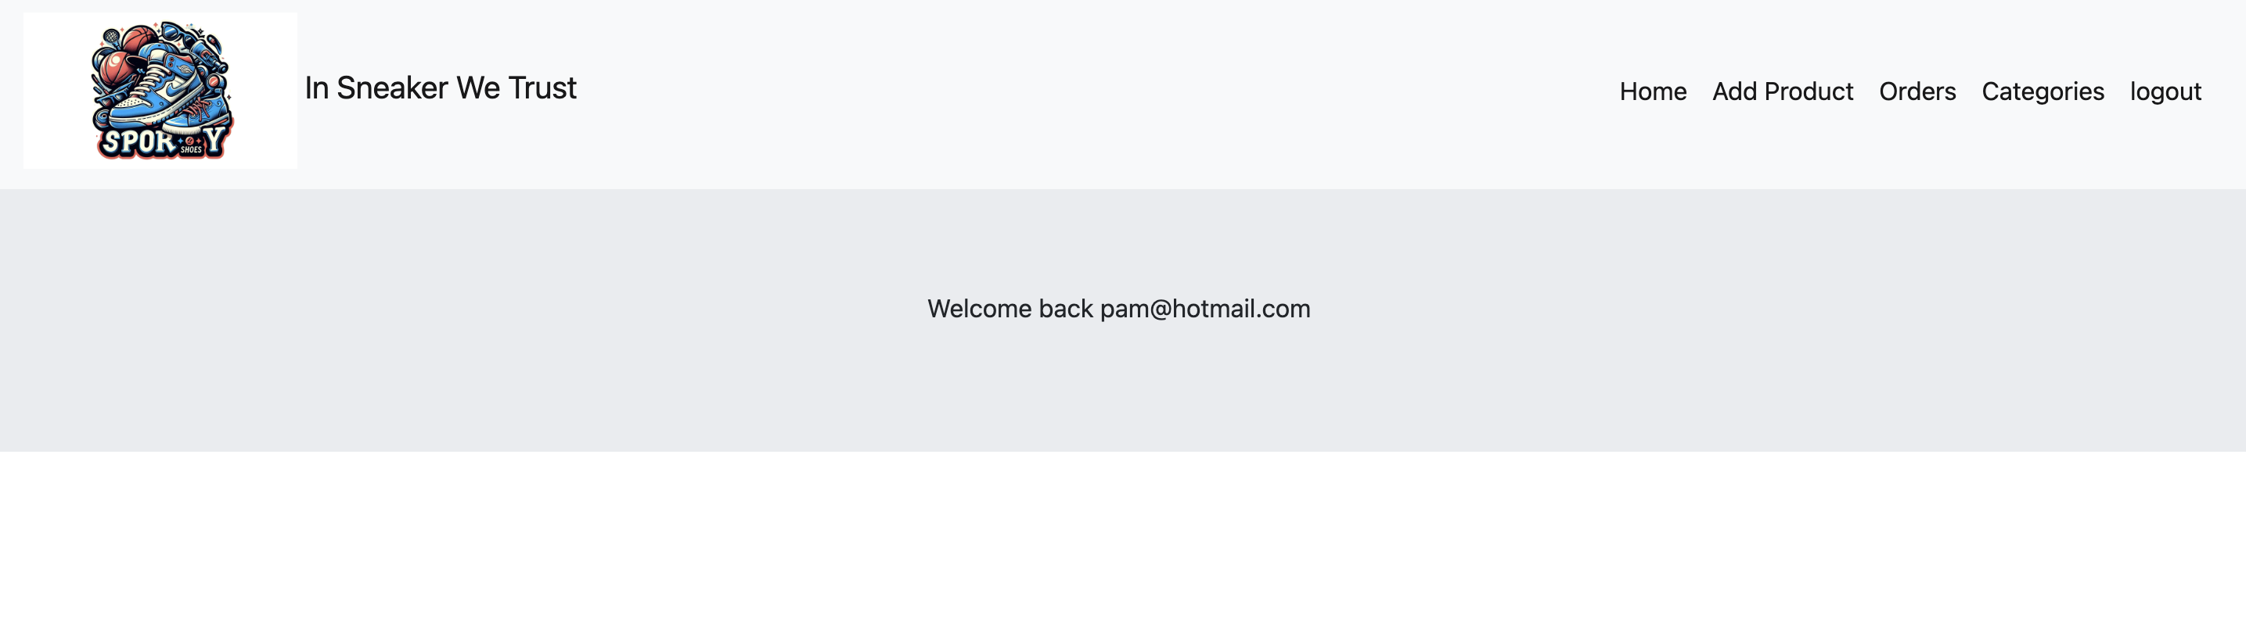

### Categories

#### Create Category

* Let start creating the categories of you products
* Click on “categories” button



* Then click in “add category” button

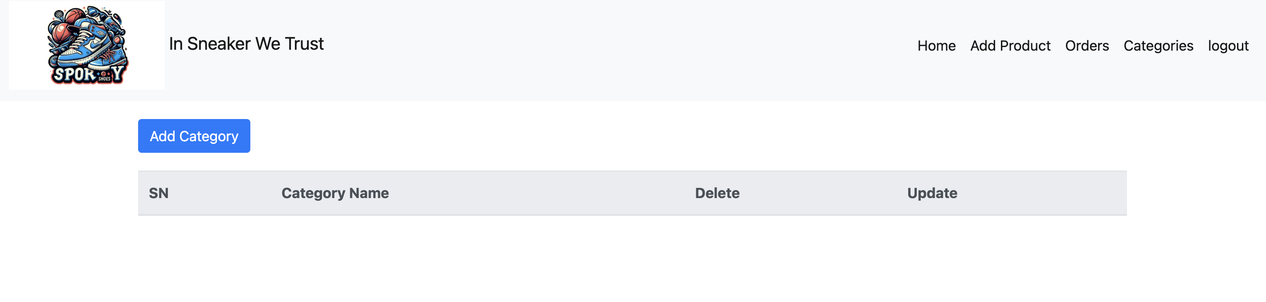

* Fill the category name and click in submit

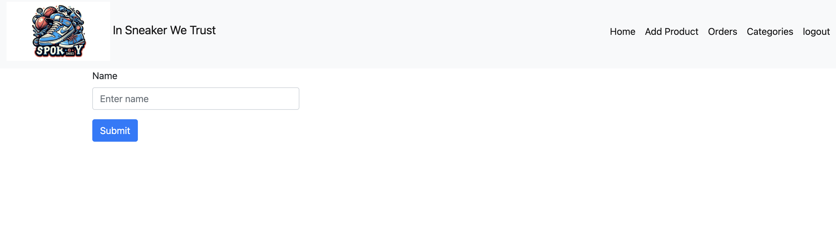

* After that you will be able to see the category created

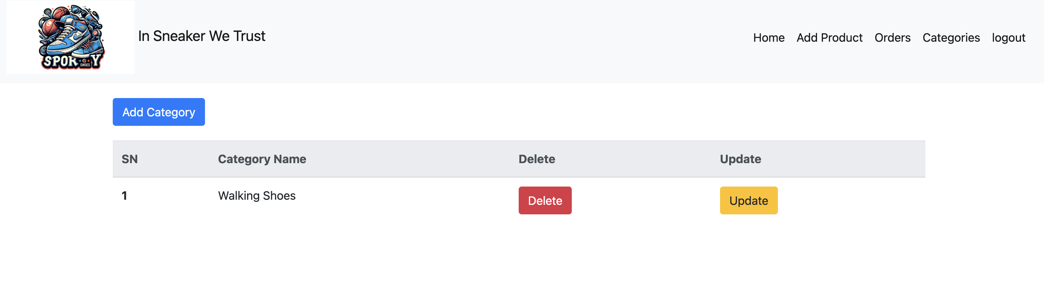

#### Update Category

* Click in the “update” yellow button



* Change the category name and click in submit

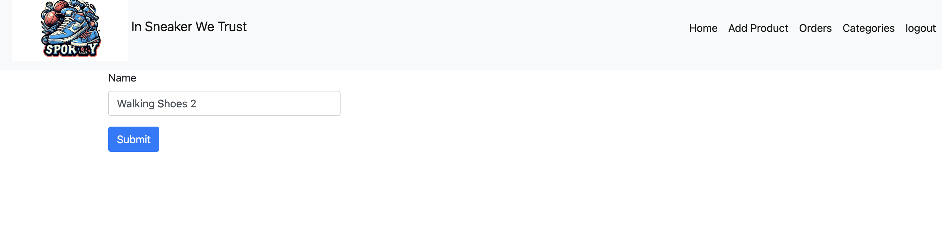

* Then your category will be updated

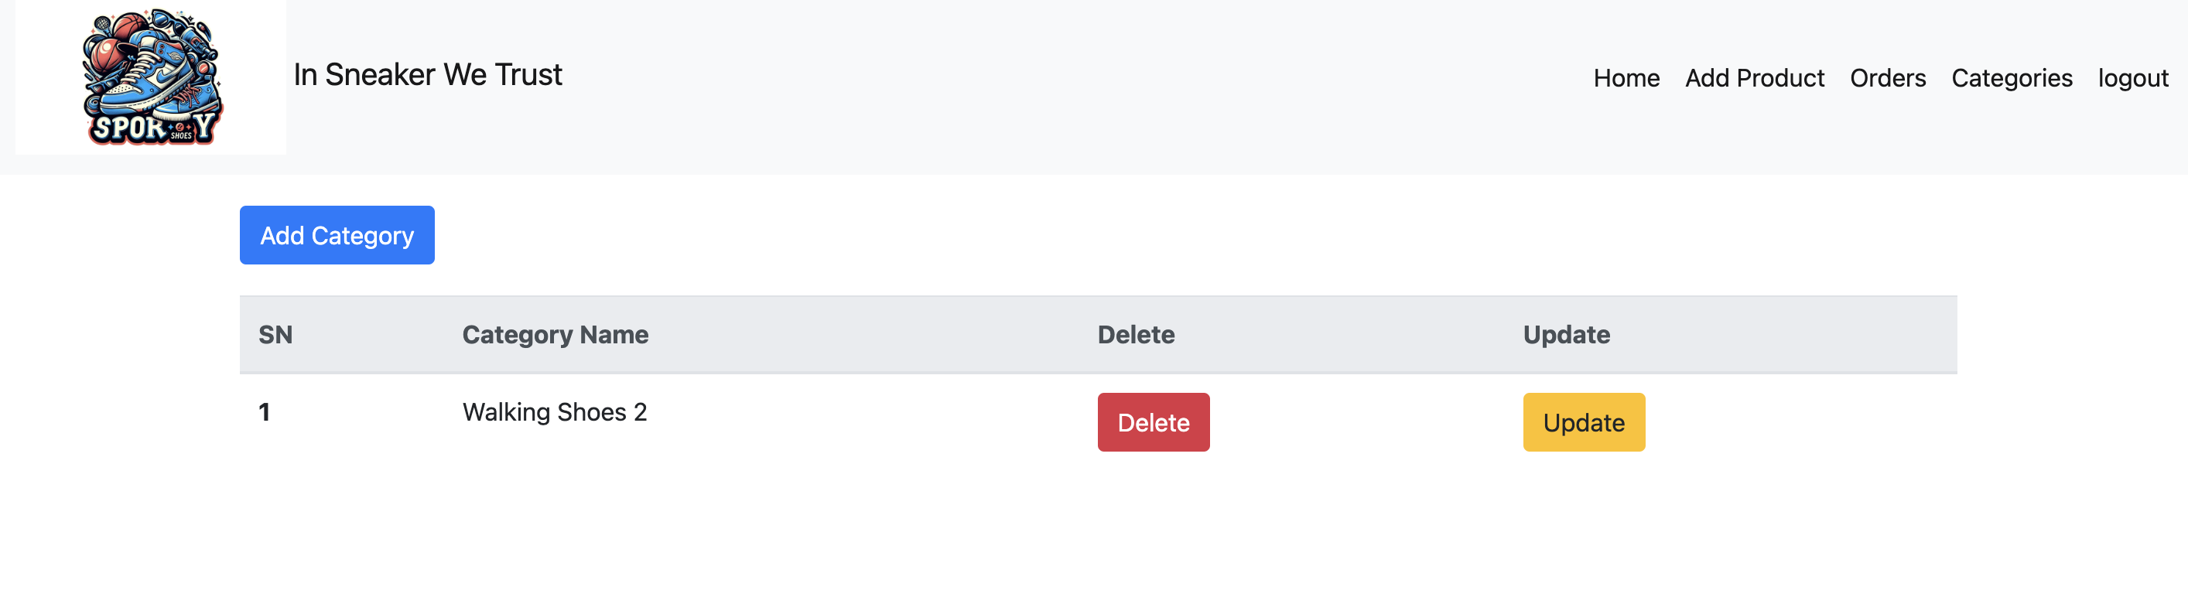

#### Delete Category

* Click on the Delete button in the category you want delete



* Then your category will be deleted

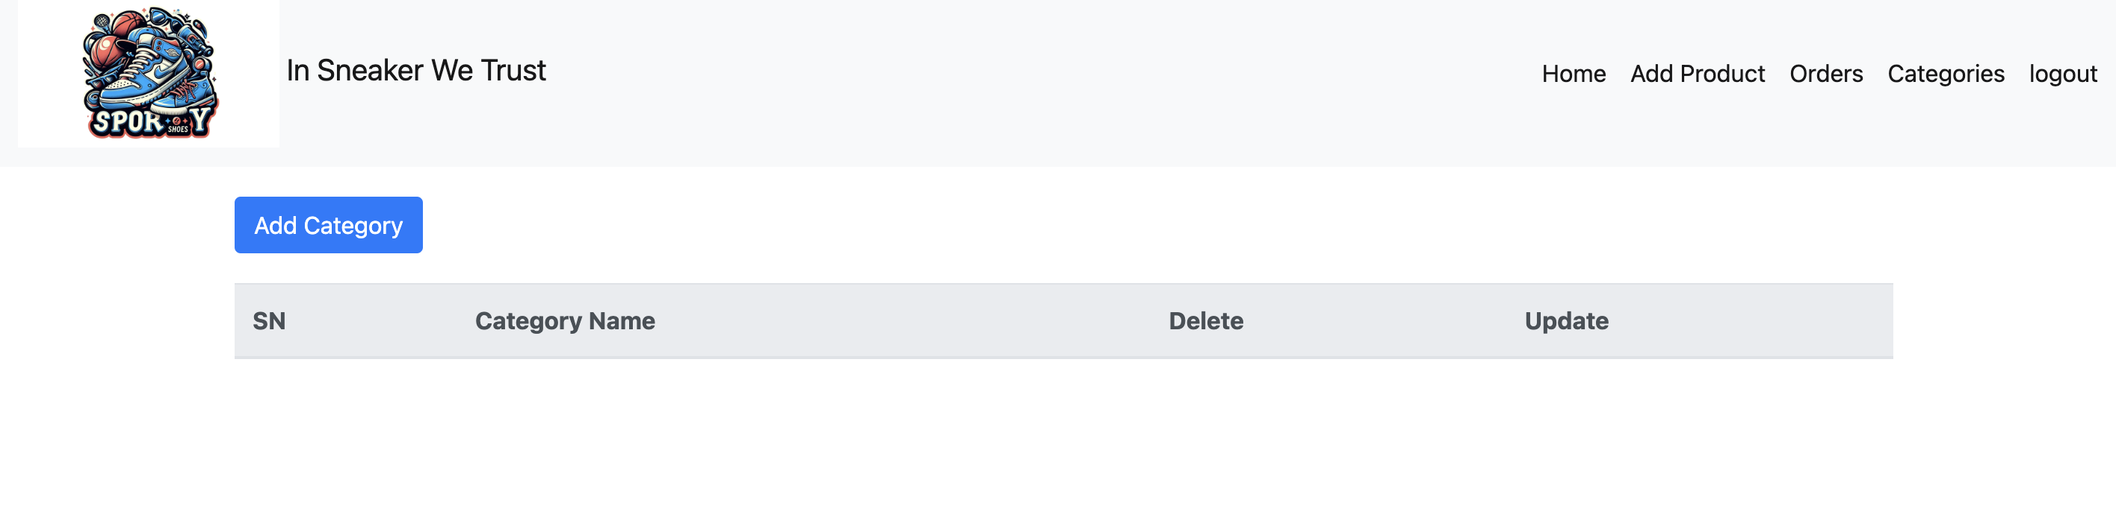

### Add Products

* Click on “Add Product” in the menu
* Fill the Product ID (PId), Product Name (PName), Price and Select the category

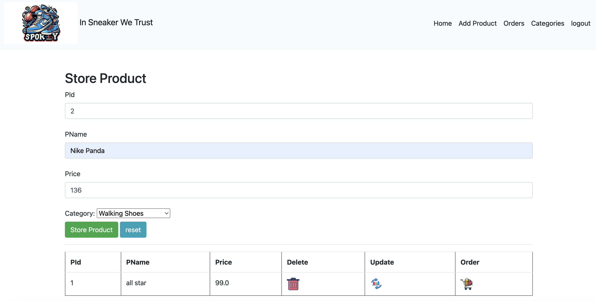

* Click in Store Product button
* Then your product will be stored in the data base

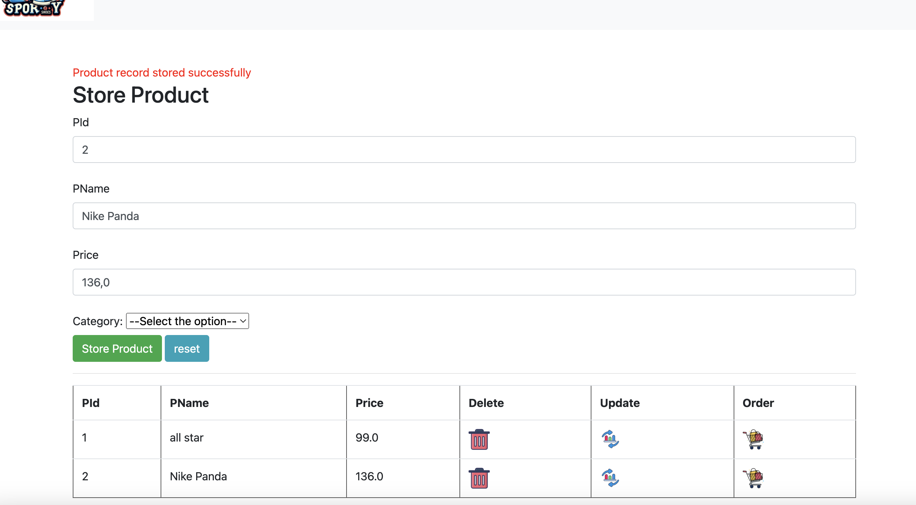

#### Update product

* To update the product click on the update button in the product you want update

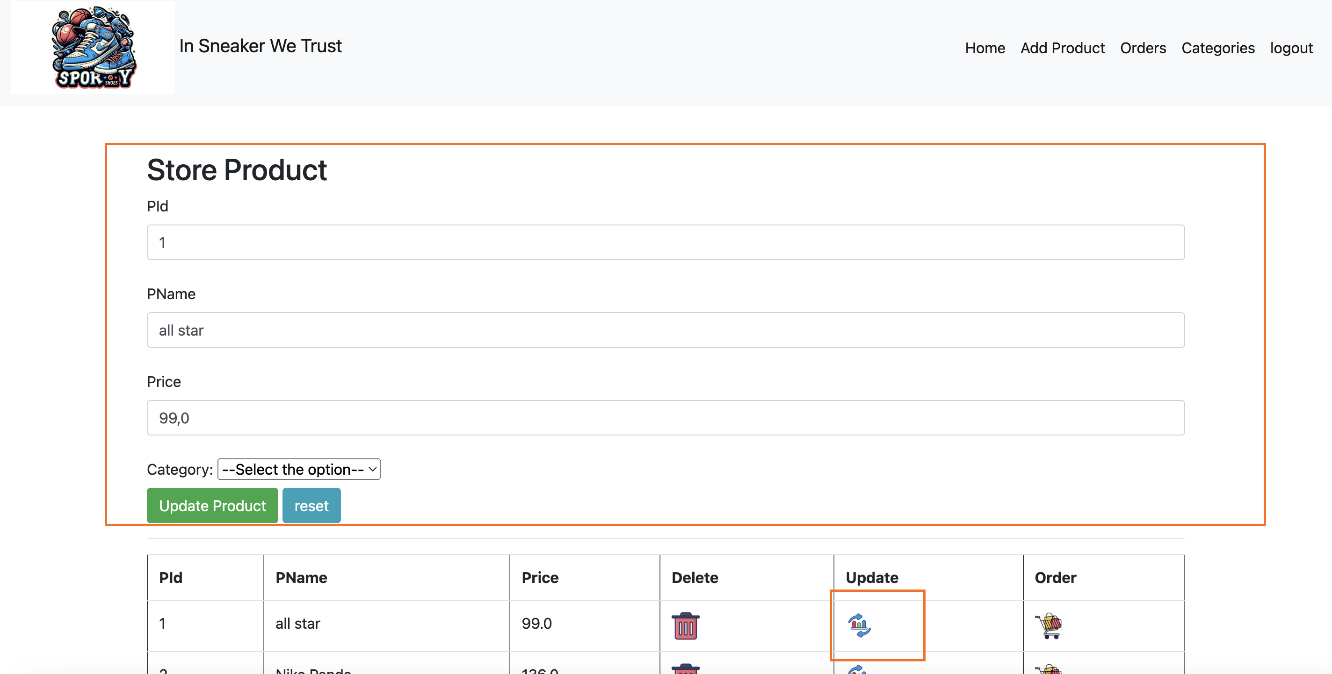

* The information of your project will be displayed in the fields
* Change it and click on Update Button
* After that you project will be updated

#### Delete Product

* To dele the product click on the trash icon button in the product you want update
* Then your product will be deleted

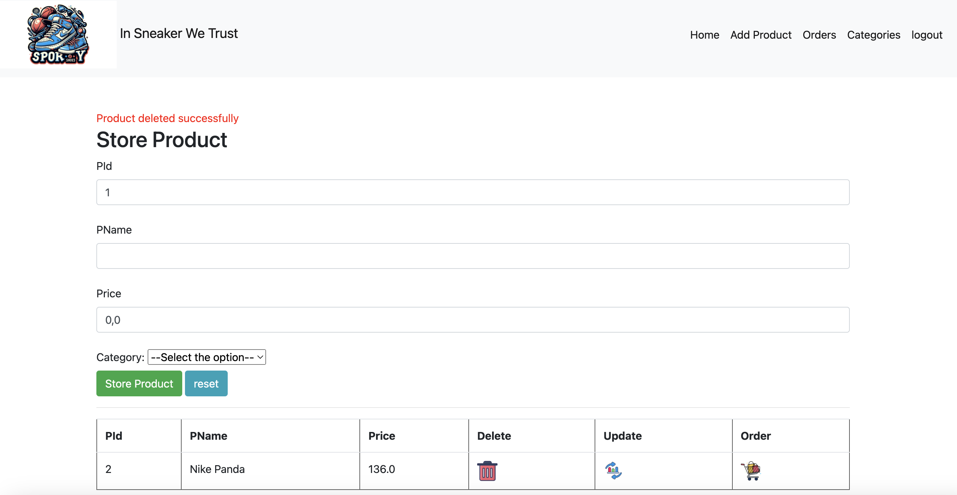

#### Place Order

* To Place the product click on the cart icon button in the product you want buy
* After that a success message will be displayed

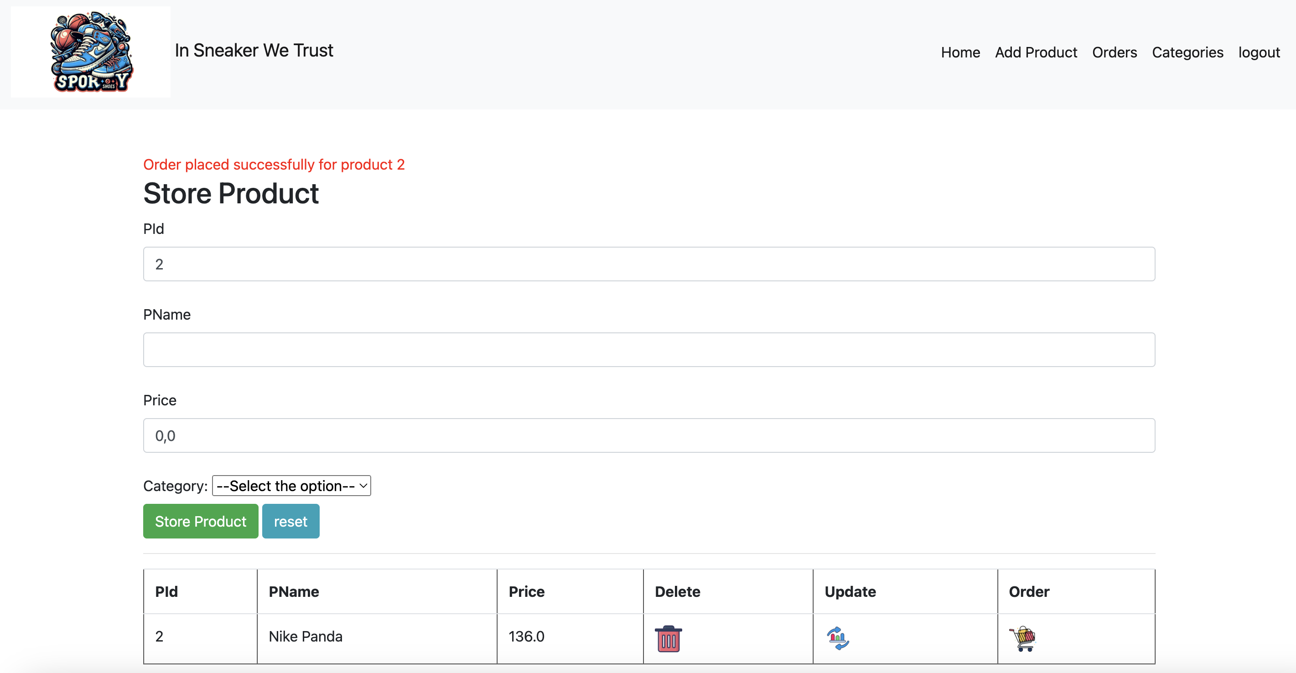

### Order Details

* To check the order details click on “orders” tab in the menu and all the orders will be displayed

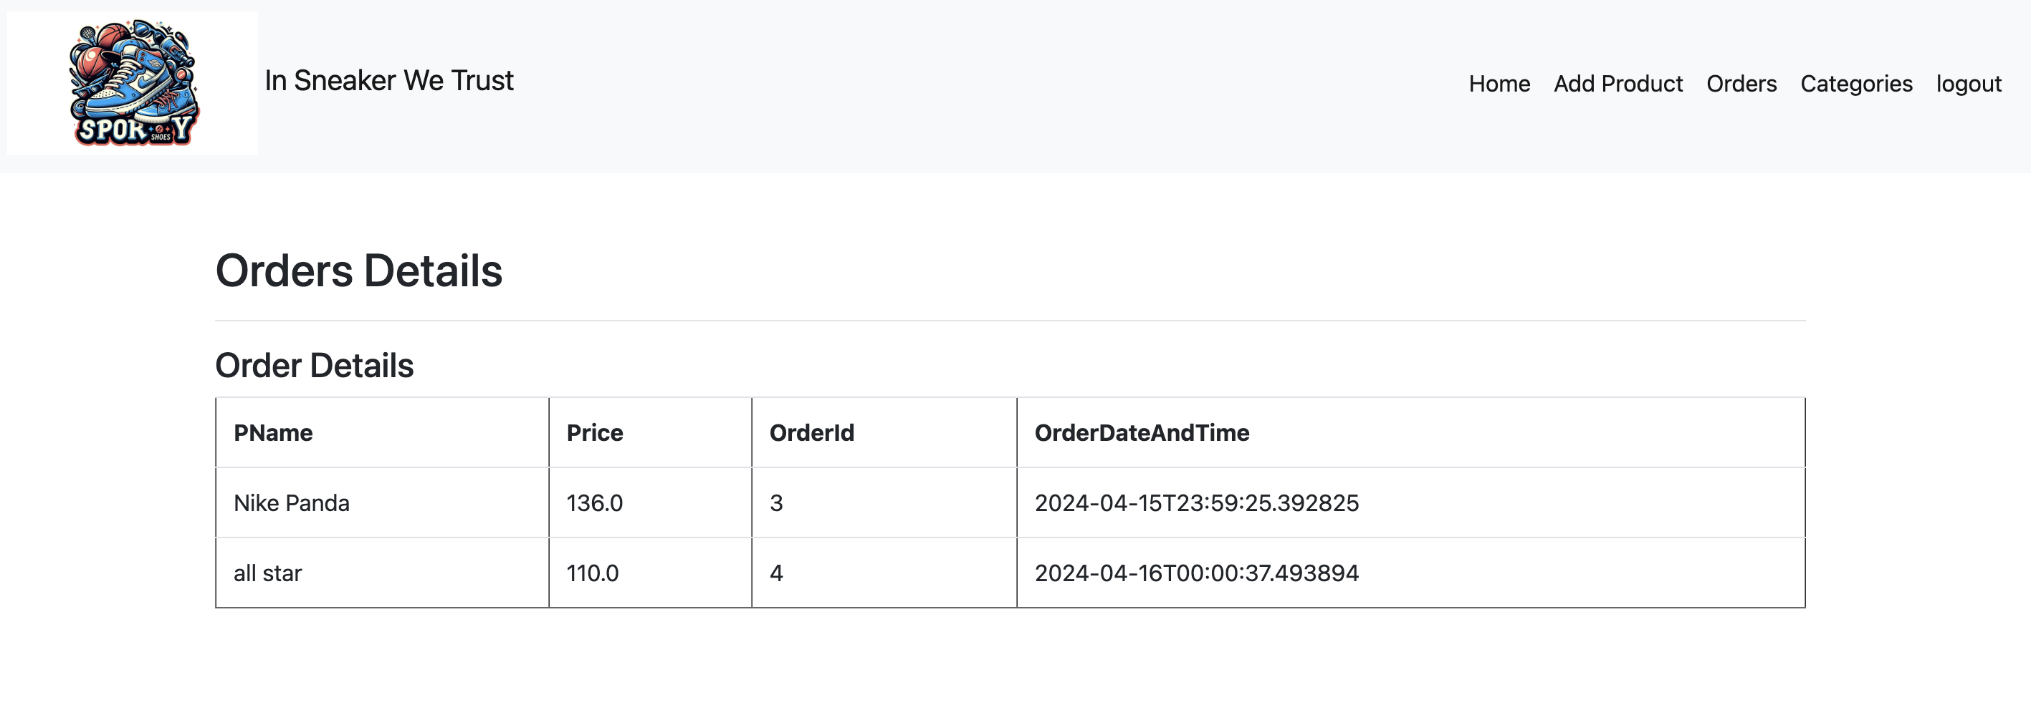

## User

* Click in the Logout button
* Navigate to <http://localhost:8080/login>
* Fill the login fields with the regular user credentials
* The regular home page will be displayed



* Click on “Shop” menu button
* Choose the product you want and click on the cart button
* Done, your product was bought

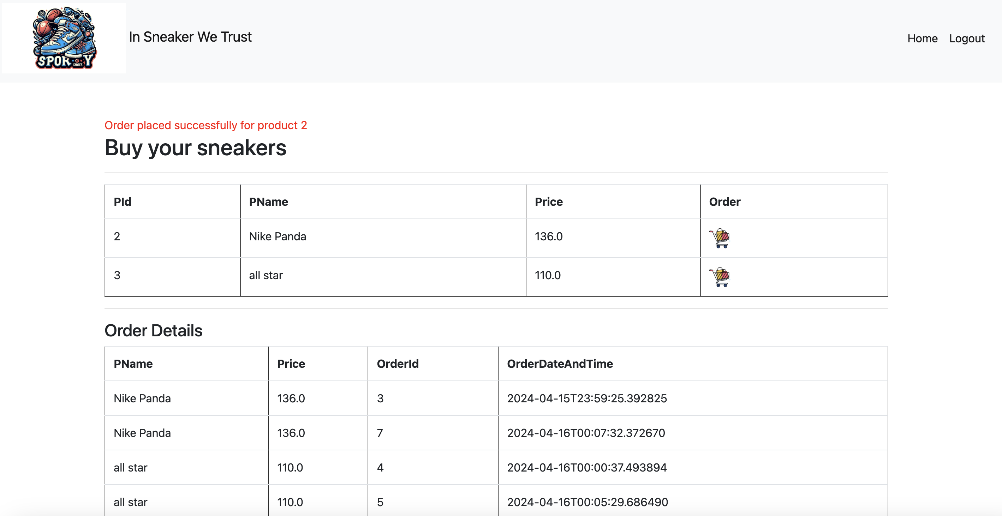

# GitHub

* Follow the git repository
  + <https://github.com/apamcamargo/SportyShoes>